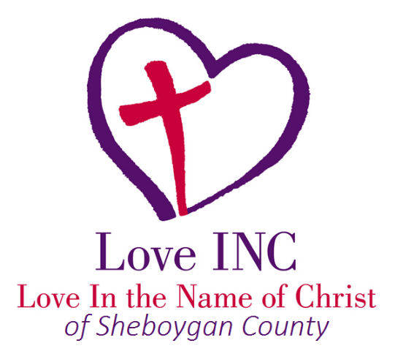
QUICK REFERENCE GUIDE OF EMERGENCY/CRISIS RESOURCES

Cultural
English as a Second Language—
Literacy Council................................ 920-892-6706
Hmong Bilingual Resources ..............877-740-4292
Hmong Family Strengthening
Hotline ..................888-345-5898 or 920-458-0808
Hmong Mutual Assistance Association
of Sheboygan ....................................920-458-0808
Latinas Unidas...................................920-331-0105
Partners Hispanic
Information Center ...........................920-459-9880
Catholic Charities (Hispanic Translation) –
…………………………………………………..920-458-5726

Emergency • Crisis
Fire, Police, Ambulance................................... 911
2-1-1 (resource hotline)........ 211 or 800-924-5514
Poison Control ..................................800-222-1222
Poison Hotline...................................800-362-3099
American Red Cross Disaster
Assistance .........................................920-231-3590
Crisis Line (Mental Health)................920-459-3151
Mobile Crisis .....................................920-459-3151

Suicide Helplines
COPE Hotline...................................262-377-2673
Mental Health Crisis Line………………920-459-3151
IMALIVE………………………………………..800-442-4673
National Suicide Prevention Lifeline
…………………………………………………….800-273-8255

Domestic Violence • Sexual Assault
Adult Protective
Services 920-467-4100
National Sexual Assault Hotline 800-656-4673
National Domestic Violence Hotline 800-799-7233 Child Protective Services 920-459-6418
Safe Harbor
(Domestic abuse shelter) 920-452-7640
Rape Abuse Incest National Network (RAINN) –
800-656-4673

Food
Salvation Army (Sheboygan) 920-458-3723
St. Vincent de Paul 920-892-4913
Community Café.……………………………920-453-0169
Pantries & Community Meals – monthly calendar at:
https://centralusa.salvationarmy.org/sheboygan/

Housing
Lakeshore CAP (rent assistance) 920-694-0041
Sheboygan County Interfaith .920-457-7272
St. Vincent de Paul (rent)……………….. 920-457-4844
Forward Service (rent *must have children) ……………….920-395-9154
Salvation Army (Sheboygan)………….. 920-458-3723
Rural Housing ……………….608-238-3448
Sheboygan Housing Authority………….920-459-3466
Sunnyside Townhouse ……………….920-459-9299

Substance Abuse

Alcoholics Anonymous……………………800-355-7318
Samaritan’s Hand 920-254-6922
Pathways to a Better Life 920-894-1373
Celebrate Recovery –
St. Paul Lutheran – Falls 920-467-6449
Hope Community Church 920-254-1762

Utilities
St. Vincent de Paul 920-457-4844
Economic Support – Energy
Assistance 920-459-3207
Salvation Army 920-458-3723

